


The
Good
News
Of Jesus Christ

How to receive the gift of eternal life.

.



Welcome…

This booklet has been given to you in order to share with you the greatest gift in the world. God has the answers to our questions. He has already provided for all our needs. He loves YOU. The purpose of this booklet is to present to you how God has expressed His love for you. Please find a comfortable chair, and take about 30 minutes or so, to thoughtfully read through these pages. Note; this booklet points us to the passages in the Bible relevant to how we can be restored into a right relationship with God.
After reading through this booklet, follow up with the person who gave you the booklet, or find a person or a church that teaches the Bible, to discuss any questions.
We want you to receive the “Good News” of Jesus Christ!
In His Love,

Good News!
The word "Gospel" means "Good News." It is the good news of how you can:
have a loving, personal relationship with God,
experience inner joy and true meaning in life,
know with certainty you will spend eternity
in heaven!
However, many people today claim that they are preaching the Gospel, yet they all seem to have different messages.

Turn from your sins.
Put Jesus on the throne
Say a sinner’s prayer

Turn your life over to Jesus.
Deny yourself.
Take up the cross

Repent and be baptized.
Make Jesus Lord of your life.
Pray to receive Christ.

Are you confused?

What really is "The Gospel"?

In this pamphlet, we will examine
what the Gospel is according to the Bible.

What about YOU?
Before we begin, how would you answer these questions?
1. What have you been told that the Gospel is?
2. If you died today and stood before God, and He asked: “Why should I let you into My heaven?”,
what would you say?
3. If you died right now, do you know with absolute certainty that you would go to heaven?

Yes! I am absolutely certain
that I would go to heaven.
OR
No, I do not know with “absolute certainty”
that I would go to heaven.

God Created Everything
The Bible begins by saying:
In the beginning God created the heavens
and the earth. Genesis 1:1
God created us to have a relationship with Him! He loves us. The early chapters of Genesis briefly describe how He created everything, and the special relationship between God and man.

The heavens are telling of the glory of God: And their expanse is declaring the work of His hands. Psalm 19:1
As we consider the beauties
and complexities of nature and the expanse of the universe, they all speak of the work of a Designer, a Creator.
The Problem of Sin
However, as in any genuine love relationship, God gave man the freedom to choose whether to love and obey Him. Through willful rejection of God, mankind’s relationship with Him became broken, As a result, our relationship with God needs to be restored.
The Word of God teaches us:
For all have sinned, and come short of the glory of God.
Romans 3:23


God is holy (spiritually light) and man is sinful (spiritually dark). Just as light and darkness cannot exist together, so Holy God cannot have a relationship with sinful man.

Separation from God
God is light, in Him
there is no darkness.
Without God, man is locked
in spiritual darkness
The result of sin is clear:
Your sins have made a barrier between you and your God
Isaiah 59:2
The wages of sin is death. Romans 6Z:23
We were dead in our sins Ephesians 2:5
Death means separation. When we die physically, our souls are separated for our bodies. The consequences of sin is spiritual death. Spiritual death means we are separated from God.

The Barrier that
Separates Man from God
is . . .

SIN

God is both holy and infinite and even the smallest sin is offensive to Him and is enough to eternally separate man from God, (James 2:10). God cannot compromise His righteous character and ignore our sin.
Man’s Efforts are Useless!
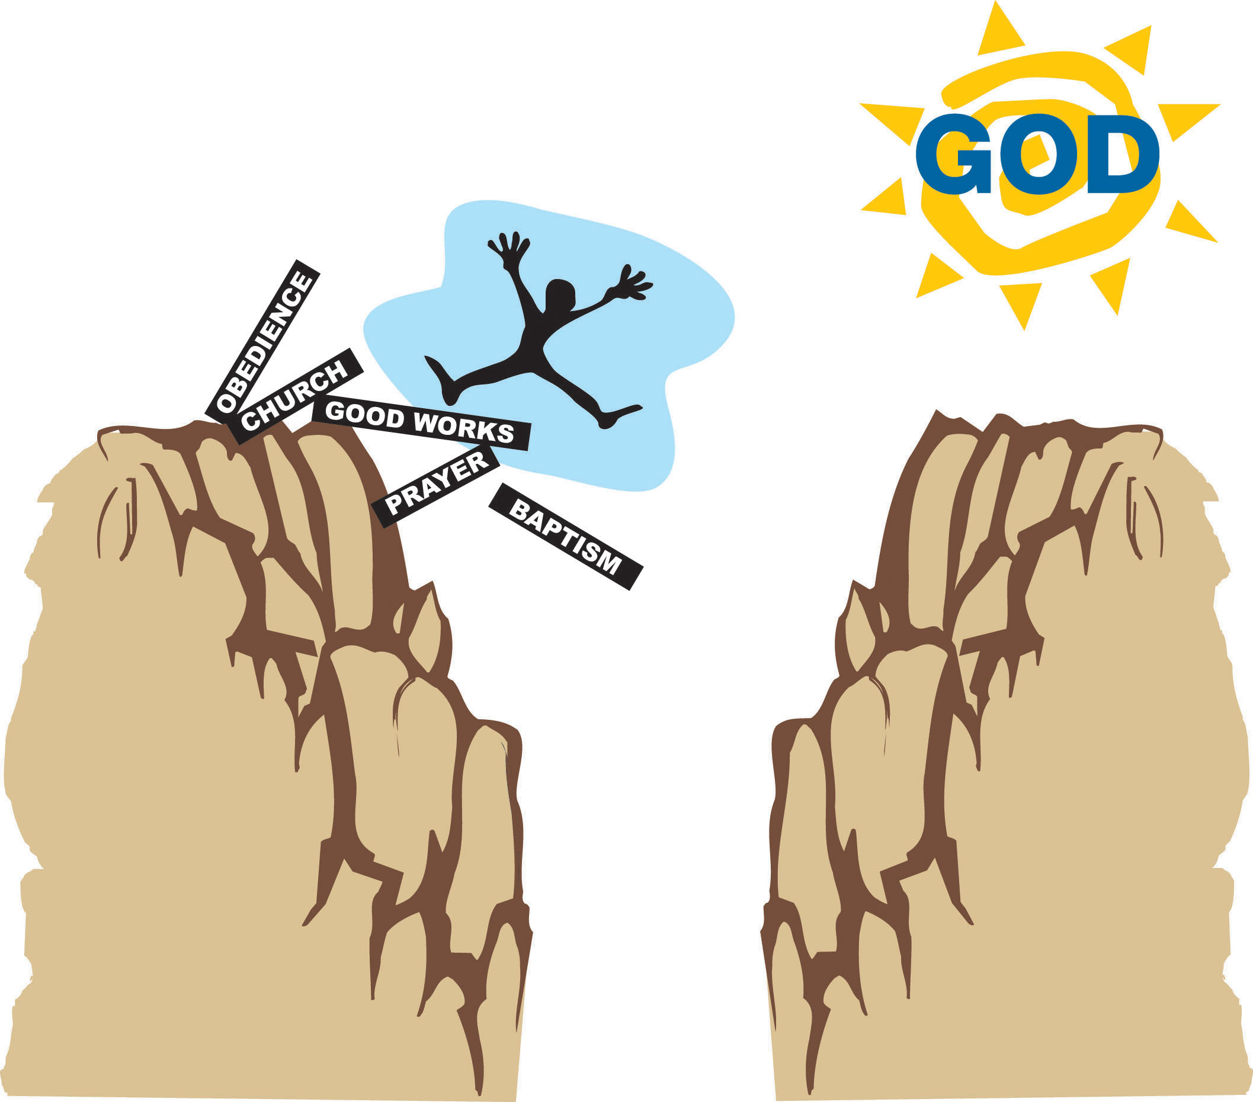
Many think they can cross the barrier by good works. In fact this is what many religions teach. If we work hard enough, we can gain God’s favor; baptism, good works, loving our neighbor, sacraments, joining a church, the list goes on and on. But the Bible teaches that no amount of good work can ever remove the barrier of sin that separates us from the Holy God.

The Bible says…
But we are all like one who is unclean, and all our righteous deeds are like a filthy garment. Isaiah 64:6
To attempt to wash away your sins through your own works is as hopeless as trying to wash a dirty face using a dirty, greasy rag. There is absolutely nothing that you can do to erase your sins and cross the barrier that separates you from God.
(Also see Haggai 2:12-14 and Luke 18:10-14)
God Must Punish Sin
Not only does sin create a barrier between God and Man, God must judge sin. God is holy and perfectly just. God’s justice requires that man be punished for the sin he has committed.
(2 Thessalonians 1:8-9, Matthew 25:46)

For the wrath of God is revealed from heaven against all ungodliness and unrighteousness of men.
Romans 1:18
The Lord, the Lord God, compassionate and gracous, slow to anger, and abounding in loving-kindness and truth; who keeps lovingkindness for thousands, who forgives iniquity, transgressions and sin; yet He will by no means leave the guilty unpunished… Exodus 34:6-7


God must judge
all sin. . .
. .and His justice is
perfect and fair


Because God is
motivated by His
Love. . .

. .He has provided a solution
To the problem of sin!
The Gospel
The word “Gospel” means “Good News.” Since we can never enter into God’s presence in our sins, God sent Jesus to die for our sins, in our place.
Moreover brethren, I declare unto you the gospel…
that Christ died for our sins according to the Scriptures, and that He was buried, and that he rose again on the third day according to the Scriptures. 1 Corinthians 15:1-4
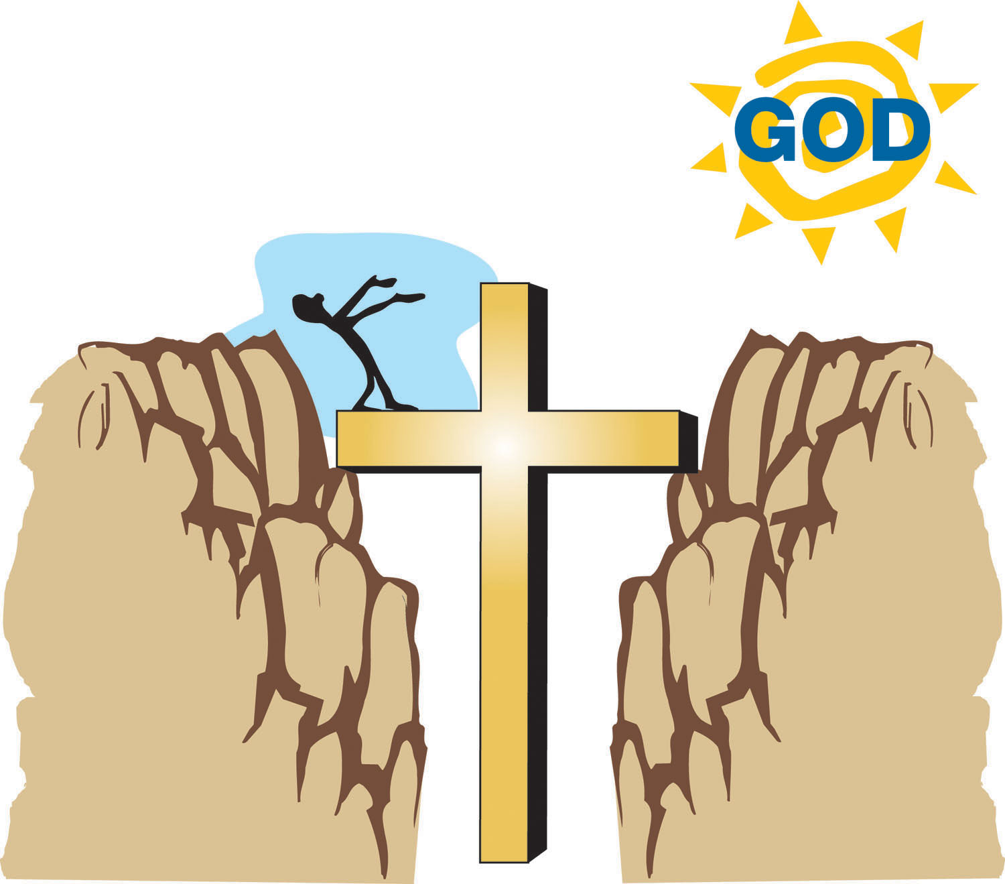
The
GOSPEL
is that Christ died on the cross
for our sins and rose again
from the dead.

?
Jesus
bridged the gap between
Holy God and Sinful man.

How did Jesus accomplish this?
The Work of Christ on the Cross...
First: Christ took our sins upon Himself
The first step in the redemption of mankind was for Jesus Christ to bear the sins of the world in His body on the cross. When Jesus hung on the cross, God took all the sins of the world (past, present and future) and placed (imputed) them on Christ.
And the Lord has laid on Him (Jesus) the iniquity (sin)
of us all. Isaiah 53:6
And He Himself bore our sins in His body on the
cross. 1 Peter 2:24

For He (God the Father) made Him Who knew no sin
(Jesus) to be sin on our behalf, that we might become the righteousness of God in Him. 2 Corinthians 5:21

Jesus
bore the
sins of the world
in His body on
the cross.

The Work of Christ on the Cross...
Substitution

Second: Christ died in our place
Since God must punish sin, He poured out His wrath upon Jesus in our place, Jesus became our “substitute”. He was punished for our sins, and died in our place.
But God demonstrated His own love toward us, in that while we were yet sinners, Christ died for us. Romans 5:8
But He was pierced through for our transgressions; He was crushed for our iniquities. The chastisement for our peace was upon Him. Isaiah 53:5
And about the ninth hour, Jesus cried out with a loud voice, saying, “My God, My God, why have You forsaken Me?” Matthew 27:46


GOD
punished
His own Son,
Jesus,
in our place!

Satisfaction (Propitiation)

Third: Christ’s death paid in Full for our sins, thereby satisfying God’s perfect justice.

Since Jesus died in our place for our sins, the perfect
demands of God’s justice was satisfied. Jesus paid for all
man’s sins, so any man who chooses to accept that pay-
ment will never have to experience the eternal wrath of God which must come upon all sin. Jesus paid in full for all
man’s sins!

We have an Advocate with the Father, Jesus Christ the righteous; and He Himself is the propitiation for our sins; and not for ours only, but for those of the whole world. 1 John 2:1-2
When Jesus therefore received the vinegar, He said, “It is finished,” and He bowed His head and gave up His Spirit. John 19:30

The phase, “It is finished” was actually an expression used in Rome in the time of Christ when a debt had been paid in full. When Jesus shouted this just
before He died, He was indicating
that He had made a perfect,
complete and final payment for sin.

(Also see Colossians 2:13-14)

The Person of Jesus Christ
How can Jesus’ death be so valuable that it can pay not only for all of your sins, but for all the sins of every person throughout all ages?
Jesus is GOD
He is eternally equal in every way with God the Father. He became man so He could die for our sins, but He never stopped being God!
And Thomas answered and said to Him: “My Lord and my God.” Jesus said to him: “Because you have seen Me you have believed. Blessed are they who have not seen Me and yet have believed. John 20:28-29
(Also see John 1:1, 14, 8:58, 10:30; Titus 2:13; Hebrews 1:8)
Historical Proof
The resurrection of Jesus Christ on the third day provides historical proof that He is who He claimed to be—God! In fact, the apostle Paul wrote:
If Christ has not been raised, your faith is worthless;
you are still in your sins. 1 Corinthians 15:16

Jesus is Risen! He proved He is God.


Why did God
become Man?
God is infinitely Holy, even the
smallest sin is infinitely offensive
to Him. As a result, an infinitate
payment must be made for the sins of
each and every person. No ordi-
nary, sinful man could pay for the
sins of others. Only an infinite
sinless God could pay the infinite
cost of sin. Jesus, while remaining
100% God, became 100% man
so that He could die in our place.
As man, He could die in our place,
as God, He is able to satisfy the demand
of God’s infinite holiness.
For there is one God, and one mediator also between God and men, the man Christ Jesus, who gave Himself as a ransom for all, the testimony borne at the proper time. 1 Timothy 2:5-6
Those who deny the deity of Jesus are rejecting the only provision available for their sins, Jesus said:
You are from beneath; I am from above. You are of this world, I am not of this world. I said therefore unto you that you shall die in your sins, for if you believe not that I am He, you shall die in your sins. John 8:23-24
An infinite payment has been made for every man’s sins. God allows each person to decide… to choose whether to accept or reject His provision for our sins. John 20:31; 1 John 5:13
?

How do we make this decision?

FAITH: Man’s response to Christ
Jesus did all the work necessary to save us from our sins. However, before we can experience the benefits that God has provided through Christ’s death on the cross, God requires that we believe (trust) in Jesus, and what He has accomplished through His death.
For God so loved the world that He gave His only begotten Son, that whosoever believes on Him will not perish, but have everlasting life. John 3:16
Jesus said: For this is the will of My Father, that everyone who beholds the Son and believes in Him, may have eternal life; and I Myself will raise him up on the last day. John 6:40
Truly, truly, I say to you, he who believes has eternal life.
John 6:47

There are over 160 verses
in the New Testament which
declare that the only condition
for receiving eternal life is FAITH
in Jesus Christ.
(Among them are John 1:7, 1:12, 3:18,
5:24, 6:29)


Faith
(TRUST)

IS THE WAY
WE STEP ACROSS THE
GAP BETWEEN GOD AND
MAN AND RECEIVE THE
GIFT OF ETERNAL LIFE
OFFERED FREELY IN
Jesus

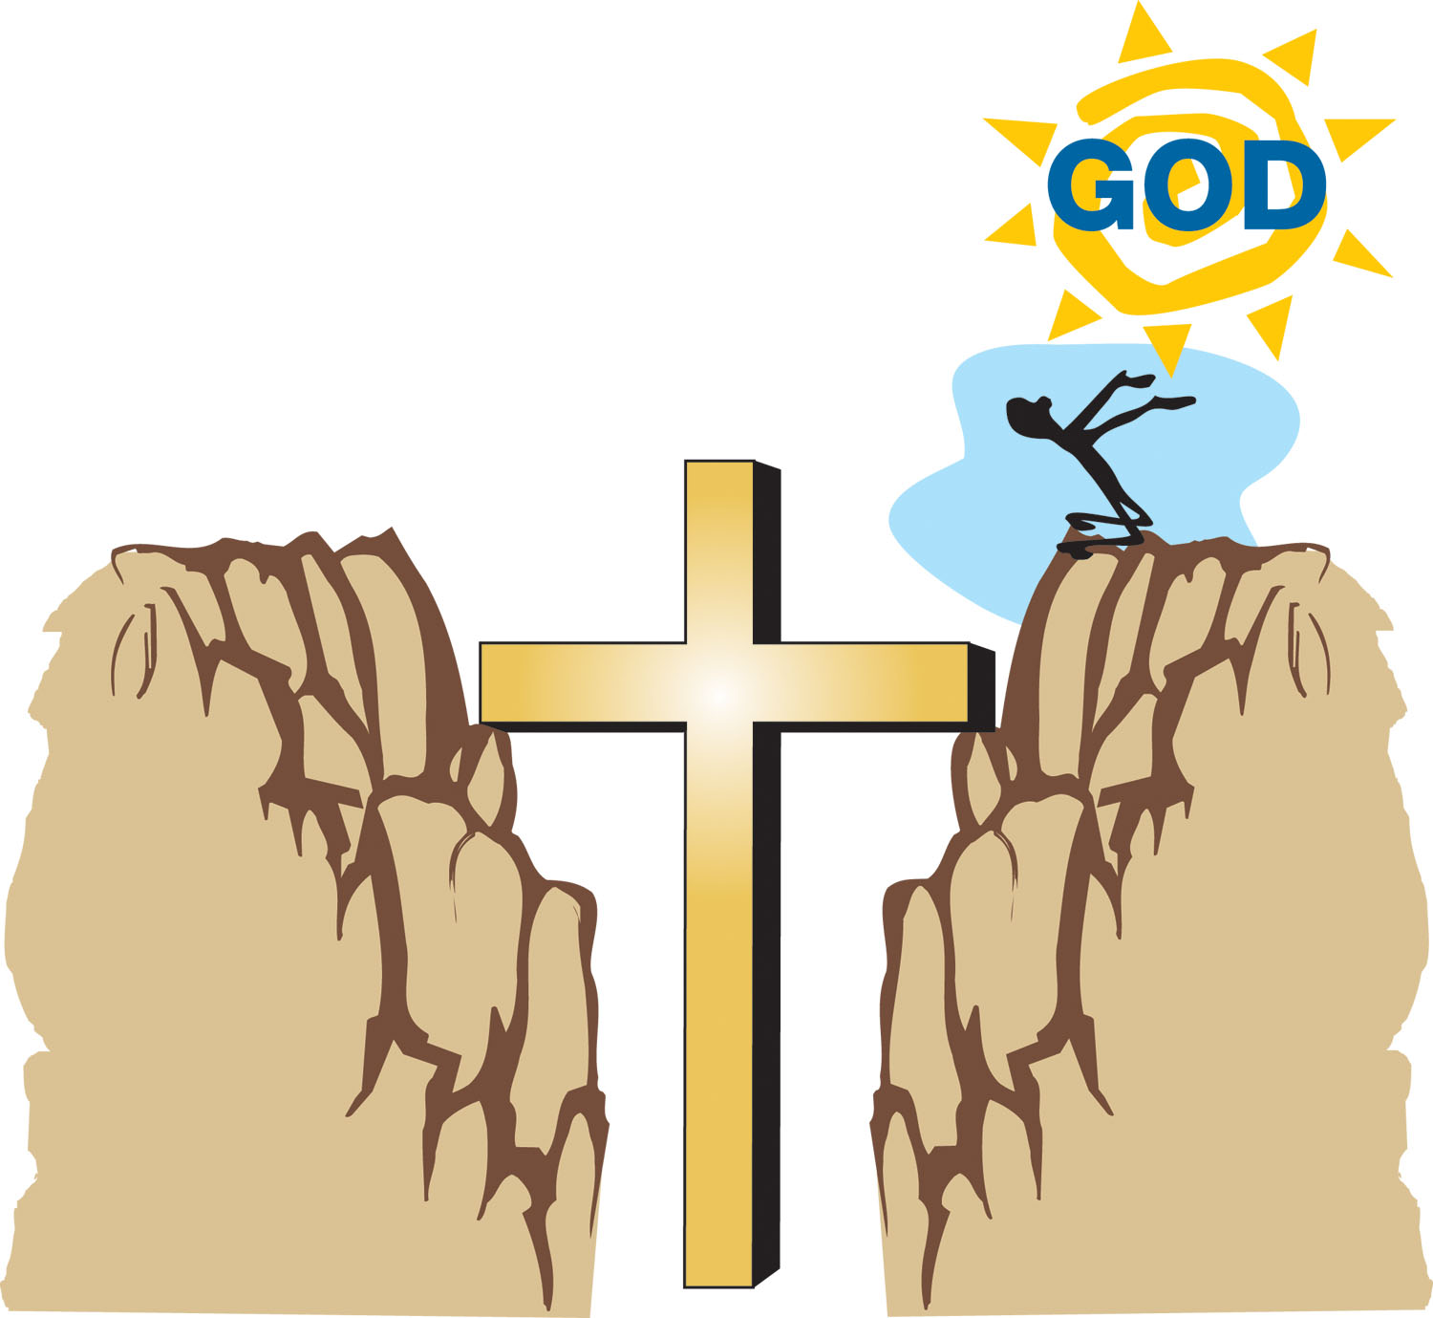

Eternal
LIFE
Spiritual
DEATH

For since, in the wisdom of God, the world through wisdom did not know God, it pleased God through the foolishness of the message preached to save those who believe.
1 Corinthians 1:21
We are unable to know God through our own wisdom or efforts. Is is only through believing in Christ that our relationship with God can be restored.
What does it mean to BELIEVE?
The words “faith” and “believe” are the same word in the original language of the Bible. Faith is a noun which refers to the action of believing. Believe is a transitive verb which expresses action. There must be an object of the action, we must believe in something.
To believe something includes three things:
FIRST

WE MUST UNDERSTAND SOME BASIC INFORMATION
For example, suppose you were trying to travel to a far away city. As you searched for a way to get to the city, someone explained to you that there is an airplane that flies to that location. The person then offers you a free ticket to fly on the plane.
SECOND

WE MUST AGREE THAT THE INFORMATION IS TRUE
Continuing with the example, after hearing about the airplane, and the offer of the free ticket, you must come to a point where you agree that the airplane does in fact fly to the far away city you are trying to reach, and that if you were to accept the ticket and board the airplane, it would take you to that city.
At this point you have intellectual agreement.
THIRD

WE MUST MAKE A DECISION TO RELY OR ENTRUAT OURSELVES TO THE INFORMATION
In order to benefit from the offer of the free ticket, and actually arrive at the far away city, you must entrust yourself to the offer. You must, by a decision of the will, decide to accept the free ticket, and actually get on the airplane.

What does it mean to
BELIEVE in Jesus Christ?
When the apostle Paul was asked, “Sir, what must I do to be saved?” Paul responded:
“Believe in the Lord Jesus Christ…”.
FIRST
You come to understand the basic information presented in this pamphlet: the impact of sin on your relationship with God, who Jesus is, and what He did on the cross.
SECOND

You agree with the information. This always involves changing our minds about what we may have previously believed about Jesus, or our own sin. The Bible calls this change of mind, “repentance”.
THIRD

You choose, by a conscious, point in time decision, to entrust your eternal relationship with God, to Jesus, and His work on the cross. This decision is expressed by a salvation prayer to God. The Bible refers to this decision as “calling on the Name of the Lord.”
Whoever believes in Him will not be disappointed. For there is no distinction between Jew and Greek, for the same Lord is Lord of all, abounding in riches for all who call upon Him; for “Whoever will call upon the Name of the Lord will be saved.”
Romans 10:11-13
To believe in
Jesus
means to entrust ourselves to Him alone, for our salvation.

Faith alone, in Christ alone.


GRACE: A Free Gift
The word “grace” means unmerited
favor, something which is given freely
without cost or obligation. For example,
if your best friend offered you a gift and
you tried to pay him for it, could you still
call it a gift? Of course not! Your friend would probably be insulted, withdraw the gift and say: “I am not trying to sell this to you. It is a gift. Do you accept my gift or not?”
The same is true with God’s offer of eternal life. People try to purchase eternal life by obeying the Ten Commandments, living a good life, going to church or some other religious work. God offers it only as a gift! There is nothing we can do to earn or deserve God’s gift of salvation.
Knowing that a man is not justified by the works of the law, but through faith in Jesus Christ, even we have believed on Christ Jesus that we may be justified by faith in Christ, and not by works of the Law, since by the works of the Law shall not flesh be justified. Gal 2:16
When man attempts to gain eternal life through his own works, he is no longer accepting God’s offer of eternal life as a free gift, that is, by “grace.” Yet it is only by His “grace” that God will save us.
But if it is on the basis of works, then it is no longer grace. Romans 11:6
For by grace you are saved through faith, and that not of yourselves; it is the gift of God, not of works that anyone should boast. Ephesians 2:8-9
Therefore, any attempt to gain eternal life through good works is to reject the only way in which God offers eternal life, that is, by His grace! We cannot make ourselves “good enough” for God. Salvation is a free gift available only through faith and apart from any human effort or good work
Will You Receive the Gift?
It is Decision Time
It is God’s desire to have an eternal relationship with you.
The Lord is not slow about His promises, as some count slowness, but is patient toward you, not wishing for any to perish, but for all to come to repentance.
2 Peter 3:9
He has provided everything to make that a reality in your life. Right now, you can decide to entrust your eternal future to Jesus Christ. Express that decision to God by praying to Him.
Whosoever will call upon the name of the Lord will be saved. Romans 10:23
Prayer is talking to God, honestly, with our own words.
This may all be very new to you. We cannot trust in Christ for you, but we can walk through with you how to pray to God.
In the privacy of your heart, between you and God, tell God that you understand and agree that you have sinned.
Next tell God that you understand the severe penalty for your sins, which is to be eternally separated from Him.
Tell God that you understand that Jesus Christ, died on the cross for your sins in your place, and then rose from the dead.

Now the next part is extremely important, because it is the only role you play in this entire process.
In the quietness of your heart, express to God that you are changing your mind, and trusting in Jesus Christ alone for your salvation, not your good works, but only in Christ.
To finish out your prayer to God, thank Him for His free gift of eternal life! Ask Him to guide you to live a life that is pleasing to Him.
Your prayer may be something like this:
“Dear God, I understand that I am a sinner, and there is nothing that I can do on my own strength, to restore my relationship with you. I believe that Jesus is God, and that He died on the cross for my sins. I am trusting totally on His death on the cross to save me from the punishment of my sins, and to receive Your gift of eternal life.”
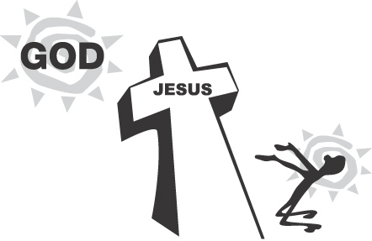
God, thank you for your infinite gift of salvation. Please
guide me now, so I can live a life that pleases You.
I pray these things in the Name of Jesus Christ,
my Savior. Amen.”

To Summarize then…
Sin separates man from God, but Jesus paid for our sins at the cross. Man can have a relationship with God only through Jesus Christ.
Jesus said unto him, “I am the way and the truth and the life, No one comes to the Father except through Me.”
John 14:6
And there is salvation in no one else, for there is no other name under heaven that has been given among men, by which we must be saved. Acts 4:12
It is God’s desire to have an eternal relationship with you.
The Lord is not slow about His promise, as some count slowness, but is patient toward you, not wishing for any to perish but for all to come to repentance.”
2 Peter 3:9
He has provided everything to make that a reality in our lives. Right now, you can decide to entrust your eternal future to Jesus Christ. We express that decision to God by praying to Him.
Whosoever will call upon the name of the Lord will be saved.”
Romans 10:13
Pray to God from the heart, with your own words…
receive God’s gift of eternal life.
This is the most important decision in life. To reject Christ is to live and die separated from God for all eternity — with no hope.
To receive Christ is to enter into a permanent relationship with God — the abundant life, a life of meaning, purpose and inner peace.

Have you Trusted in Christ?
How would you answer these questions now?
1. What is the Gospel?
2. If you died tonight and stood before God, and He asked: “Why should I let you into My heaven?”, what would say?
3. If you died right now, do you know with absolute
certainty that you would go to heaven?

If you have trusted in Christ for salvation….

Welcome to the Family of God!!
But as many received Him, to them He gave the right to become children of God, even to those who believe in His Name. John 1:12
Jesus compared salvation to being born spiritually. You have just been “born again.” If you have a Bible, read through John 3. Jesus explains to Nicodemus, a religious leader, that one must be born again to enter into the kingdom of God. You are now spiritually alive! Jesus said:
Truly, truly, I say to you, he who hears My word, and believes Him who sent Me, has eternal life, and does not come into judgment, but has passed out of death into life.”
John 5:24
He who has the Son has the life, he who does not have the Son of God does not have the life.” 1 John 5:12
?

Now What?

You need to Grow Up !…
As a new believer, the Bible compares you to a spiritual baby. You need to grow spiritually. God wants to transform you from the inside out to become more and more like Jesus Christ!
(Romans 12;1-2)
Here are some very important first steps:
- Each day spend some time reading the Bible. The Bible is your source of truth, it is spiritual food. Start with reading through the book of John, then the book of Galatians. They are both in the New Testament.
Like newborn babies, long for the pure milk of the word, that by it you may grow in respect to salvation. 1 Peter 2:2
Man shall not live on bread alone, but on every word that proceeds out of the moth of God. Matt 4:4
2. Each day spend some time with God in prayer. You now have a relationship with God! He desires us to talk with Him.
3. Become part of a local church that teaches from the Bible. God has provided the church as an environment where you can grow spiritually. The apostle Paul compares the church to a body, where all the members grow together.
4. Share the Good News of Christ with a friend!

Not only has the Lord given us the gift of Eternal Life, but He has also invited us to enter into His Kingdom Work.
Follow Me, and I will make you Fishers of Men Matthew 4:19

Healthy Spiritual Growth


1 Read Your Bible 2 Pray to God

3 Join a Good Church 4 Share the Good News

Acknowledgements
The purpose of this booklet is to provide a clear and accurate presentation of the Gospel of Jesus Christ. The general idea and much of the content in this booklet is taken from a similar booklet entitled “The Gospel” written by Ron Shea of Clear Gospel Crusade.
Special thanks to Kathy Mauch for the art work.
Another resource used for this pamphlet is the Evangelism Explosion training developed by Dr. James Kennedy.
The Bible quotations are from the New American Translation.
Thank you for taking the time to read this booklet. If you have further questions, meet with the person who gave you this booklet. You should also seek out a church that teaches the Bible.
Your fellow servant
Ray Cardwell


For God so loved the world,
that He gave His only begotten Son,
that whoever believes in Him should not perish,
but have eternal life. John 3:16

“Ask and it will be given to you; seek and you will find; knock and it will be opened to you. For everyone who asks receives, and he who seeks finds, and to him who knocks it will be opened.” Matthew 7:7-8

For God so loved the world that He gave His only begotten Son, that whoever believes in Him should not perish, but have eternal life.” John 3:16

But these have been written that you may believe that Jesus is the Christ, the Son of God, and
believing you may have life in His name.”
John 20:31

EquippedToDisciple.org

